**Circuit**

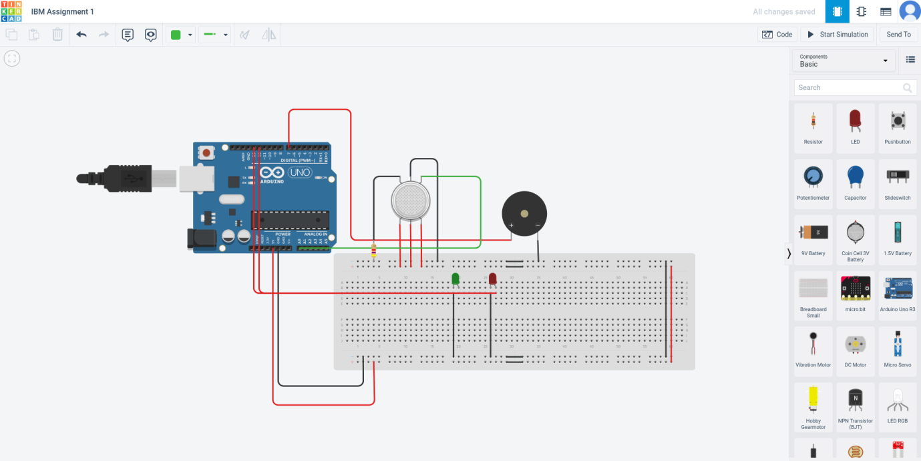

**Circuit with Code**

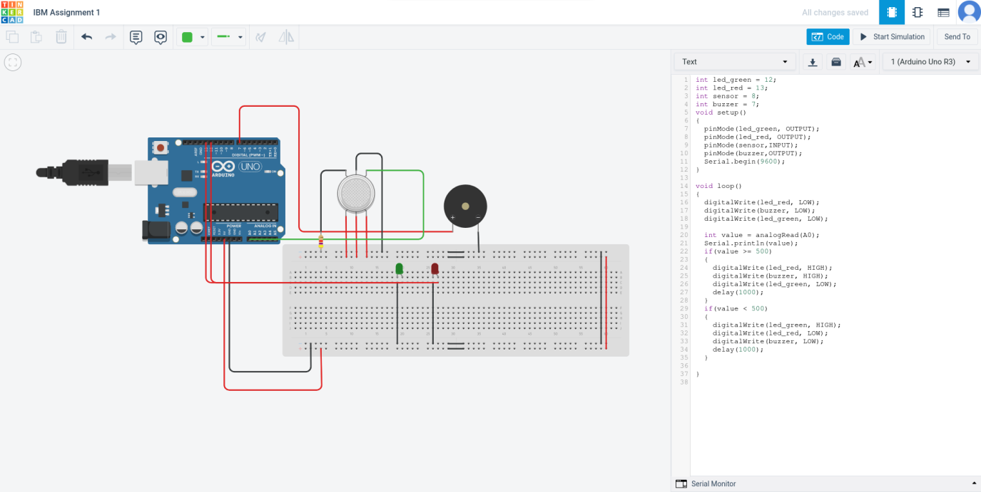

**CODE**

int led_green = 12;

int led_red = 13;

int sensor = 8;

int buzzer = 7;

void setup()

{

pinMode(led_green, OUTPUT);

pinMode(led_red, OUTPUT);

pinMode(sensor,INPUT);

pinMode(buzzer,OUTPUT);

Serial.begin(9600);

}

void loop()

{

digitalWrite(led_red, LOW);

digitalWrite(buzzer, LOW);

digitalWrite(led_green, LOW);

int value = analogRead(A0);

Serial.println(value);

if(value >= 500)

{

digitalWrite(led_red, HIGH);

digitalWrite(buzzer, HIGH);

digitalWrite(led_green, LOW);

delay(1000);

}

if(value < 500)

{

digitalWrite(led_green, HIGH);

digitalWrite(led_red, LOW);

digitalWrite(buzzer, LOW);

delay(1000);

}

}

**OUTPUT**

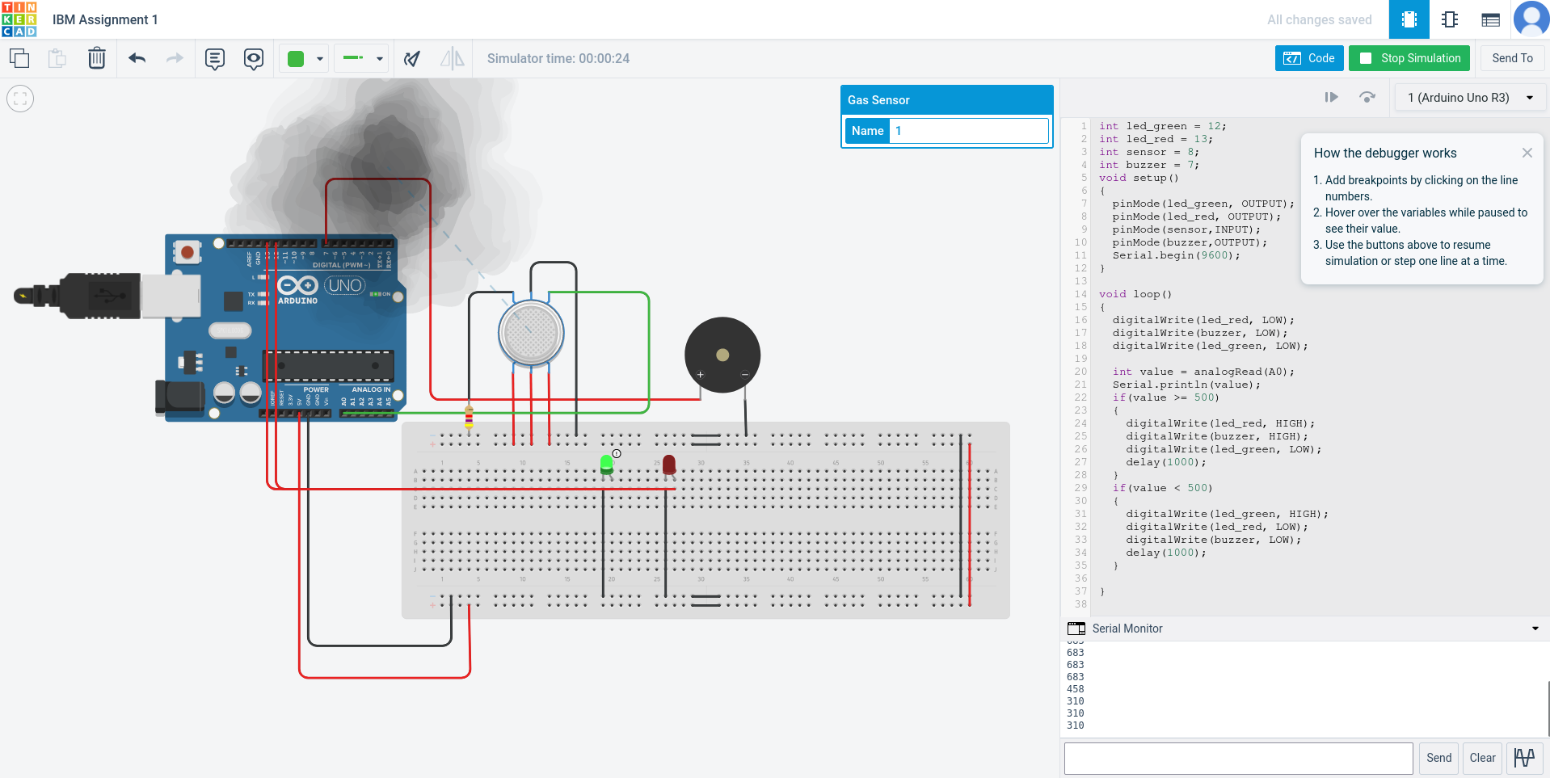

**OUTPUT 1**

